SQL ASSIGNMENT 01.
Querying . Filtering . Sorting . AND/OR/NOT . TOP . SET Operators . IN/NOT IN . JOINs Subqueries
Student Name. Mir Murtaza Hussain
Roll No. 916780
Course Name. Multi Cloud Data Engineering (MCDE)
Instructor Name. Muhammad Umair Ashraf
Due Date. 03-Nov-2026
Part 1: Querying Data (SELECT)
1.1 Display all columns and rows from Customers
SQL

SELECT * FROM Sales.Customers;

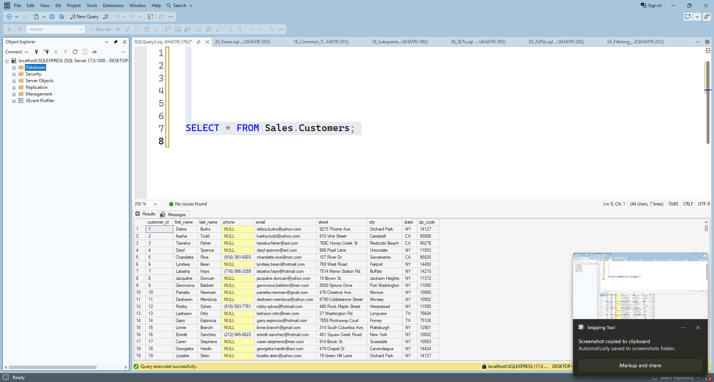
1.2 Display FirstName, LastName and Country
SQL

SELECT first_name, last_name, city
FROM Sales.Customers;

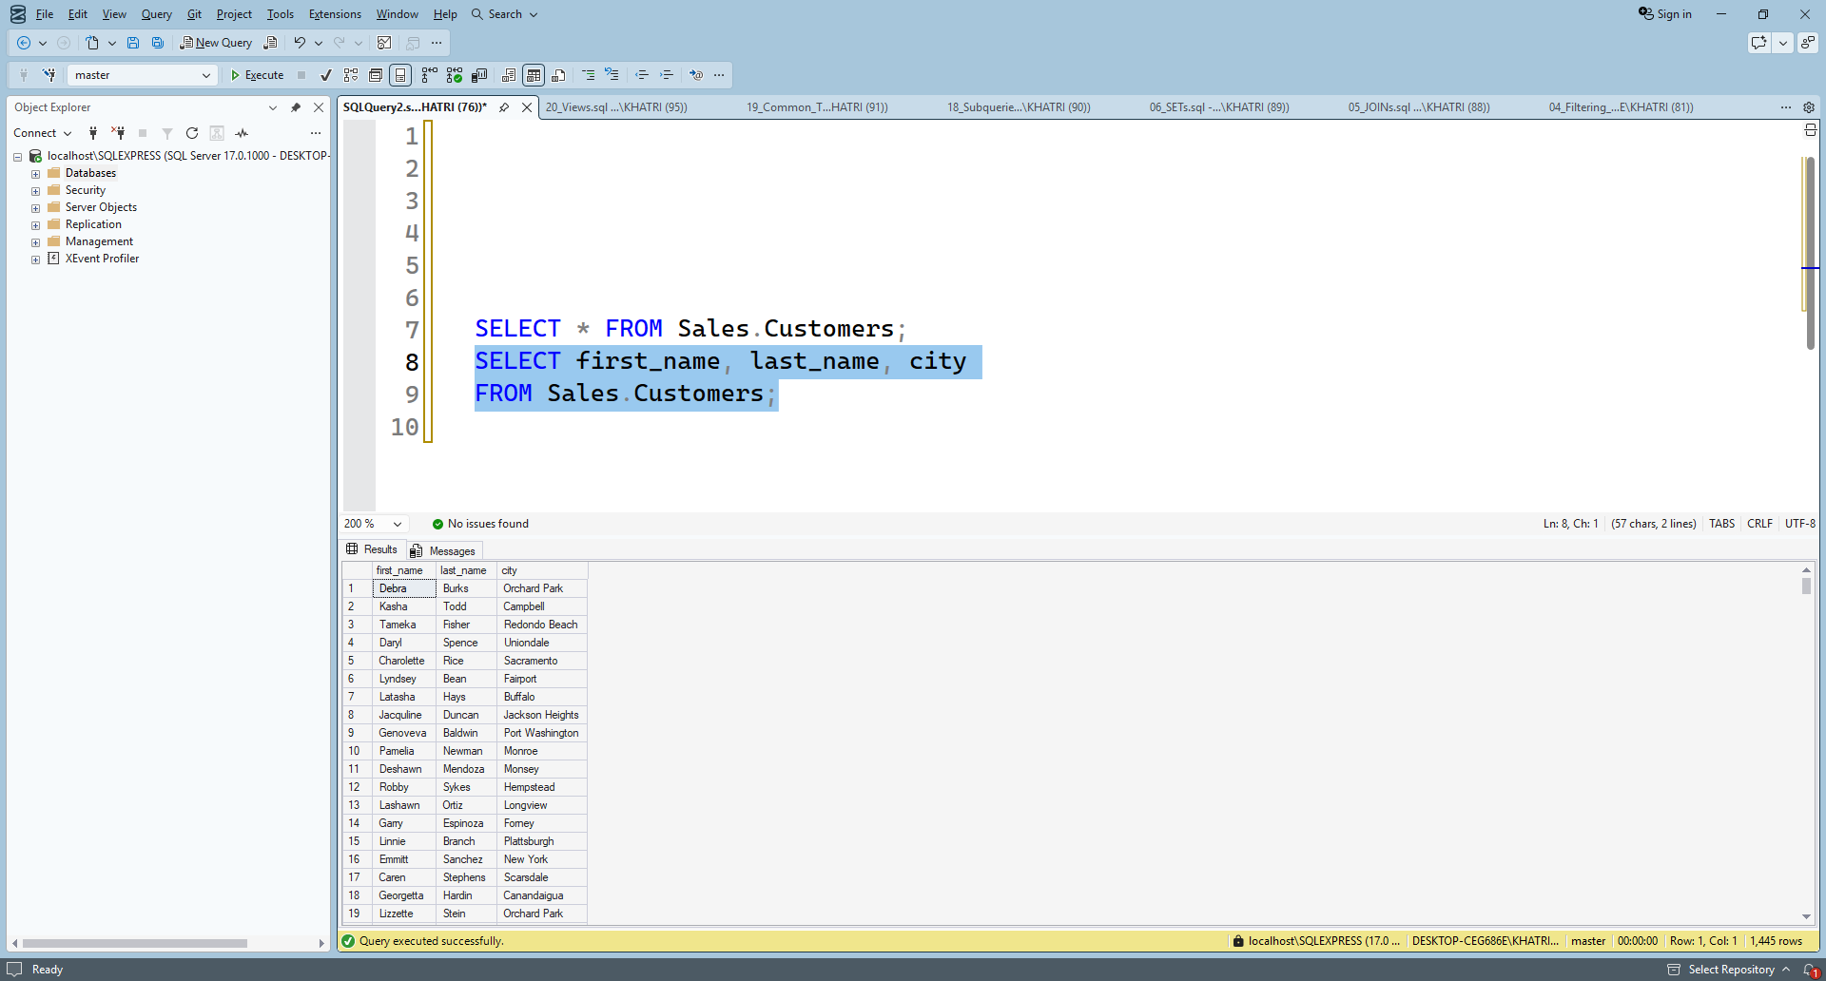
1.3 Rename ProductName and Price as Product and UnitPrice
SQL

SELECT product_name AS Product,
list_price AS UnitPrice
FROM production.products;

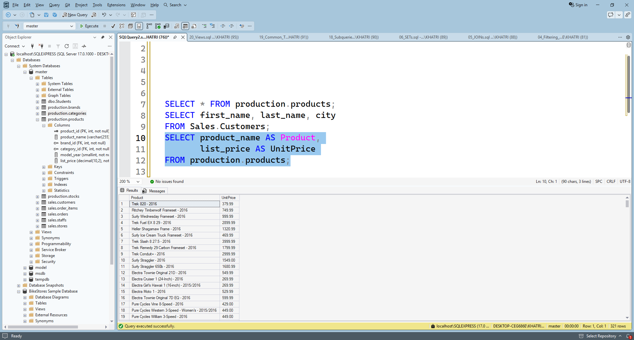

1.4 Display each country only once
SQL

SELECT DISTINCT city
FROM Sales.Customers;

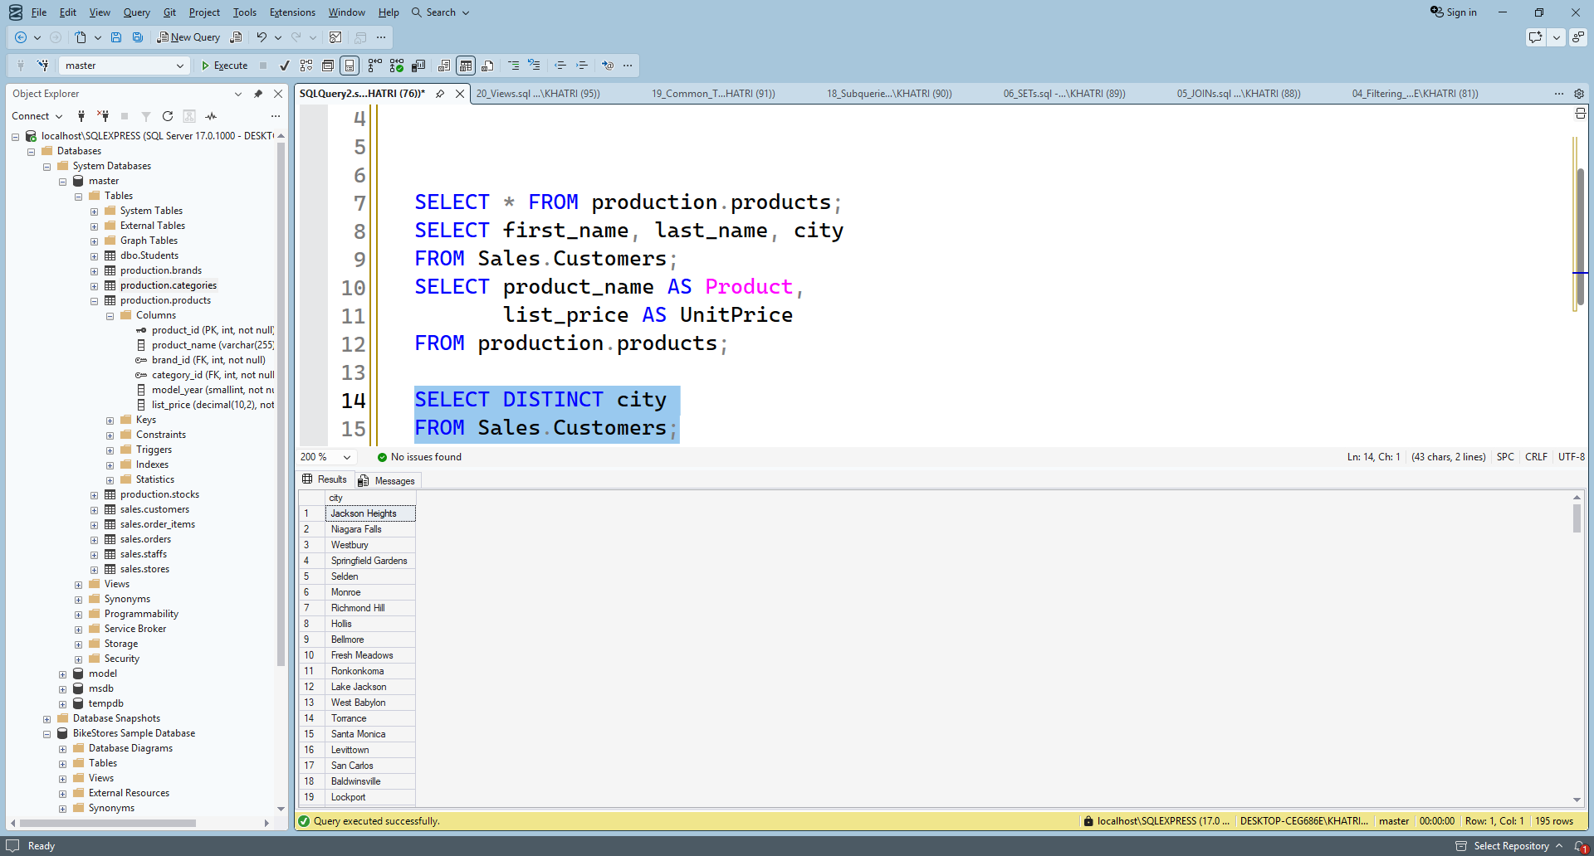

1.5 Display salary increased by 10%
SQL

SELECT FirstName,
Salary,
Salary * 1.10 AS SalaryAfterRaise
FROM Employee;

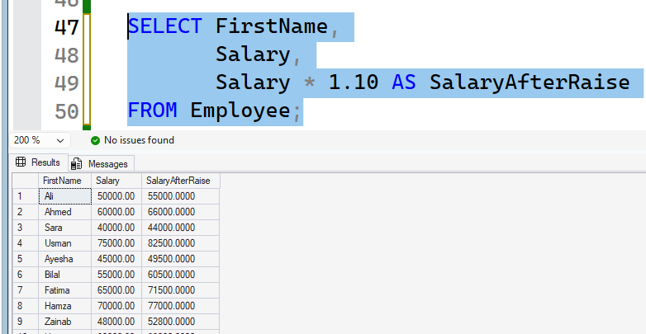

Part 2: Filtering Data (WHERE)
2.1 Customers who live in USA
SQL
SELECT *
FROM Customers
WHERE country = 'USA';

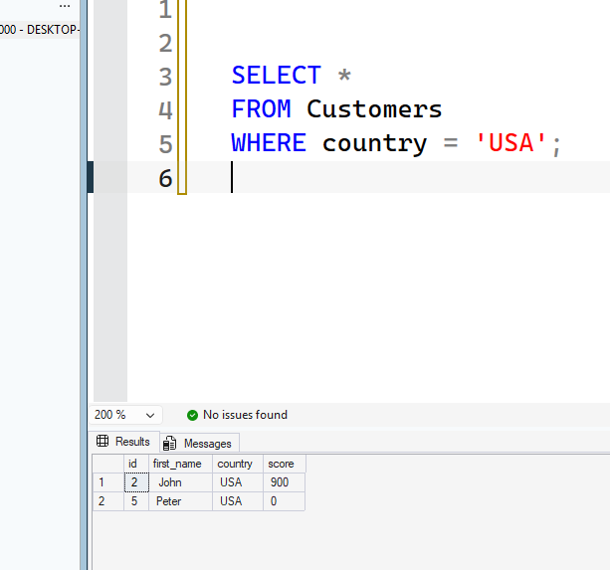

2.2 Products costing more than 100
SQL

SELECT product_name, list_price
FROM production.products
WHERE list_price > 200

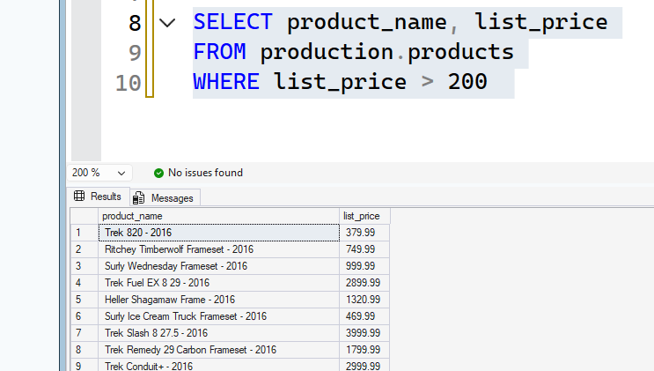
2.3 Employees earning 60000 or less
SQL

SELECT FirstName, Salary
FROM Employees
WHERE Salary <= 60000;

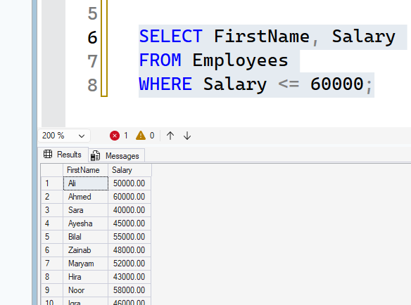
2.4 Orders whose status is not Cancelled
SQL

SELECT *
FROM Orders
WHERE Status = 'Cancelled';

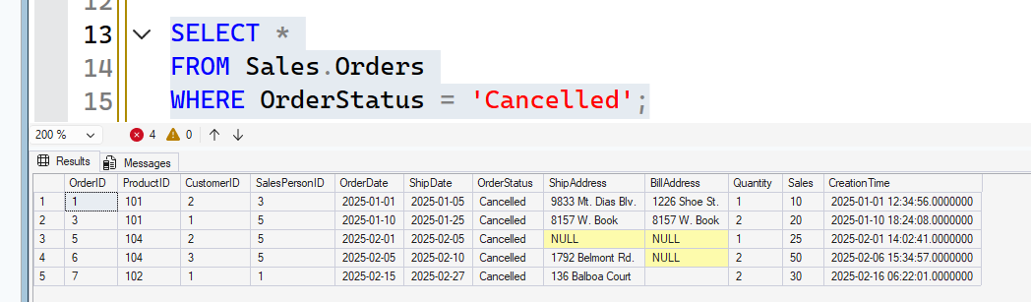
2.5 Customers whose LoyaltyPoints are NULL
SQL

SELECT FirstName, LastName
FROM Costomer
WHERE LoyaltyPoints IS NULL;

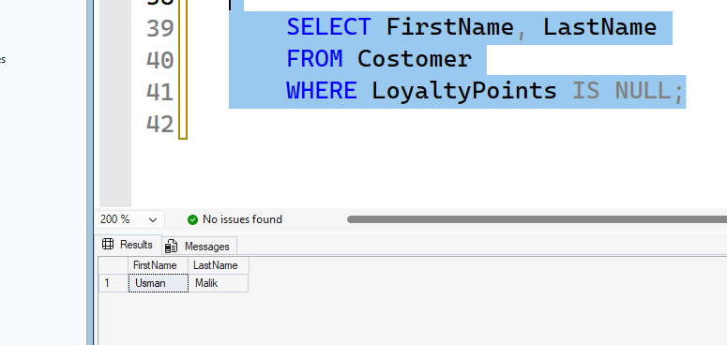
Part 3: Sorting Data (ORDER BY)
3.1 Products from lowest to highest price
SQL

SELECT product_name, list_price
FROM production.products
ORDER BY list_price ASC;

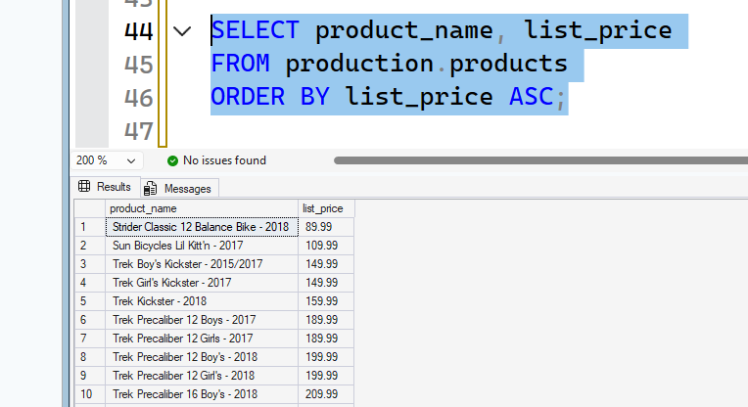
3.2 Customers from oldest to youngest
SQL

SELECT firstname , Age
FROM Costomer
ORDER BY Age DESC;

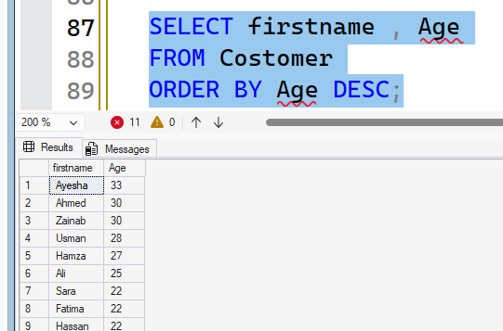
3.3 Employees alphabetically by LastName
SQL

SELECT *
FROM Employees
ORDER BY LastName ASC;

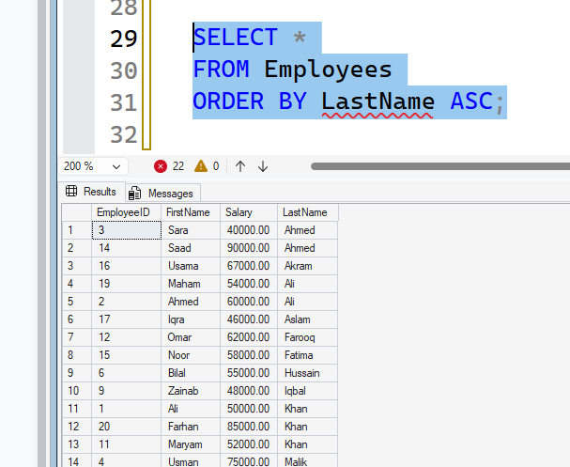
3.4 Sort by Country and then LoyaltyPoints
SQL

SELECT FirstName, Country , LoyaltyPoints
FROM Costomer
ORDER BY Country DESC,
LoyaltyPoints ASC;
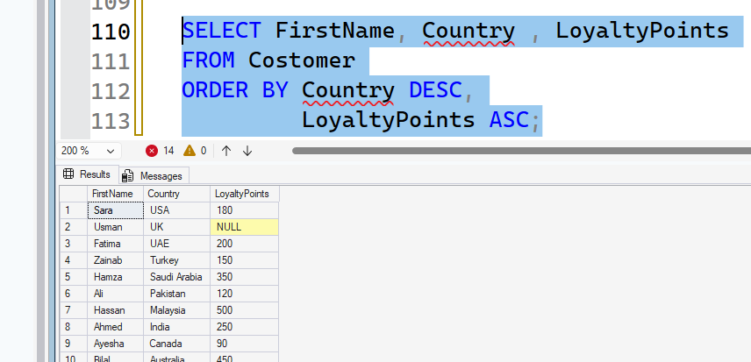
3.5 Delivered orders, most recent first
SQL

SELECT order_id, order_date
FROM sales.orders
ORDER BY order_date DESC;

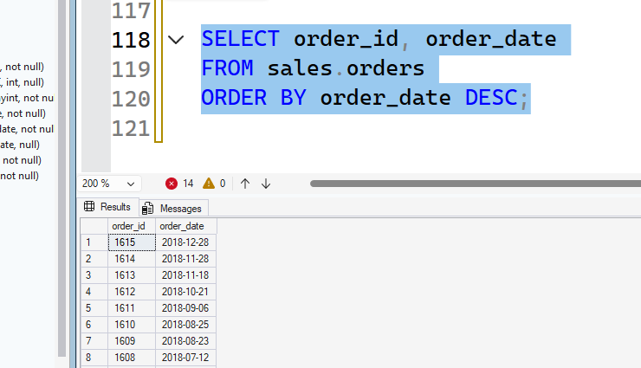
Part 4: AND, OR and NOT
4.1 Customers in Pakistan who are older than 30
SQL

SELECT *
FROM Costomer
WHERE Country = 'Pakistan'
AND Age > 30

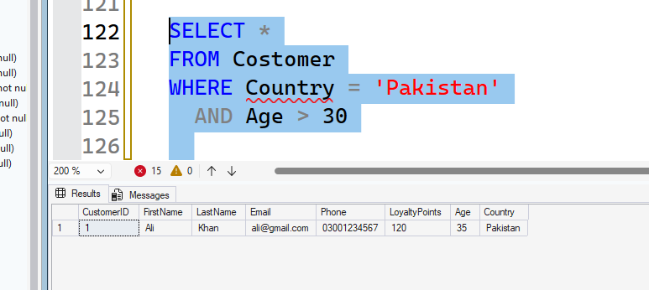
4.2 Furniture products or products costing less than 10
SQL

SELECT *
FROM Sales.Products
WHERE Category = 'Furniture'
AND Price < 10;

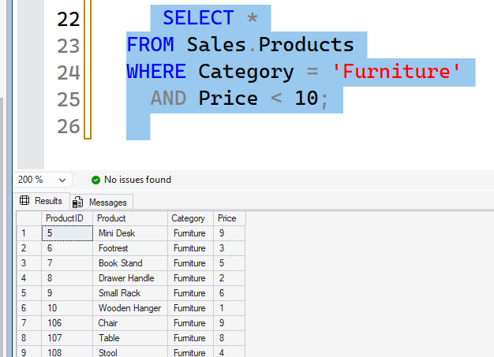
4.3 Sales employees earning more than 50000
SQL

SELECT *
FROM Sales.Employees
WHERE Department = 'Sales'
AND Salary > 50000;
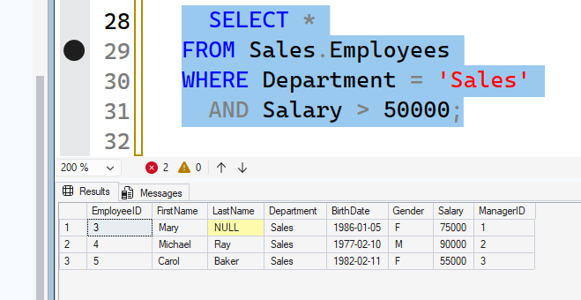
4.4 Customers who do NOT live in Pakistan
SQL

SELECT *
FROM Costomer
WHERE NOT Country = 'Pakistan';

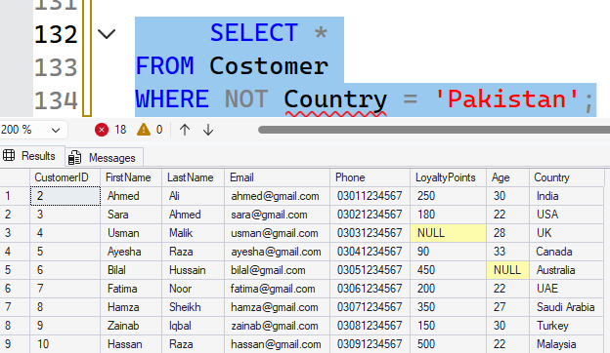

4.5 Customers in the USA or UAE with more than 400 LoyaltyPoints
SQL

SELECT *
FROM Costomer
WHERE (Country = 'USA' OR Country = 'UAE')
AND LoyaltyPoints > 400;

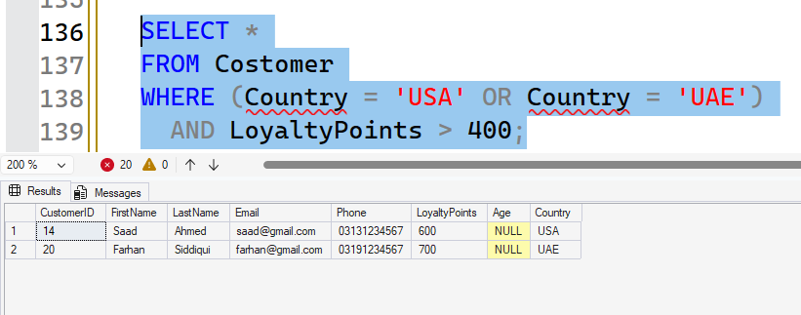
Part 5: TOP
5.1 First 3 rows of Customers
SQL

SELECT TOP 3 *
FROM Customers;

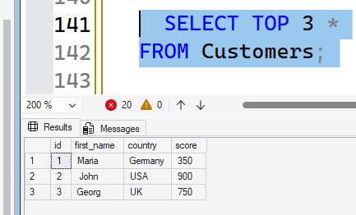
5.2 Five most expensive products
SQL

SELECT TOP 5 Product , Price
FROM sales.Products
ORDER BY Price DESC;

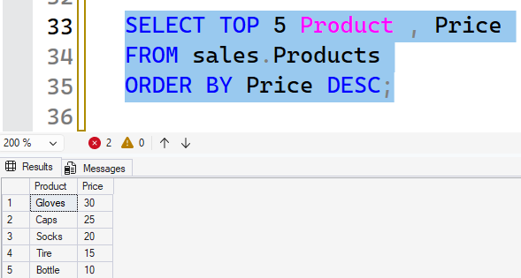
5.3 Three youngest customers
SQL

SELECT TOP 3 FirstName, Age
FROM Costomer
ORDER BY Age ASC;

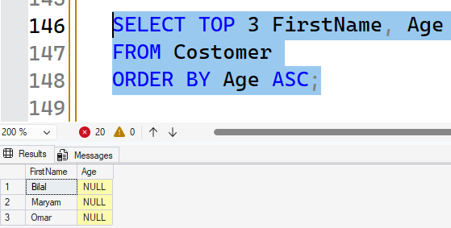
5.4 Highest-paid employee, only one row
SQL

SELECT TOP 1 FirstName, LastName, Salary
FROM Employees
ORDER BY Salary DESC;

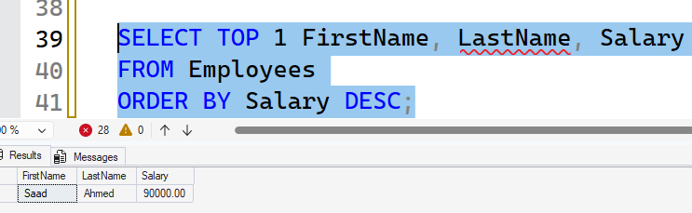
5.5 Two most recent Delivered orders
SQL

SELECT TOP 2 OrderID, OrderDate
FROM sales.Orders
WHERE OrderStatus = 'Delivered'
ORDER BY OrderDate DESC;

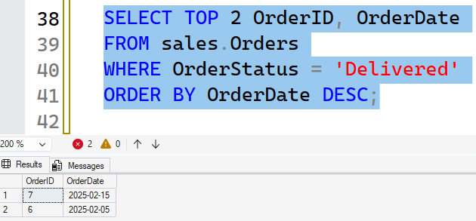
Part 6: SET Operators
6.1 Combine customers and employees without duplicates
SQL

SELECT FirstName, LastName
FROM sales.Customers
UNION
SELECT FirstName, LastName
FROM sales.Employees;

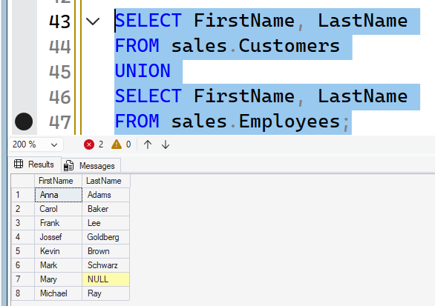
6.2 Combine customers and employees, including duplicates
SQL

SELECT FirstName, LastName
FROM sales.Customers
UNION ALL
SELECT FirstName, LastName
FROM sales.Employees;

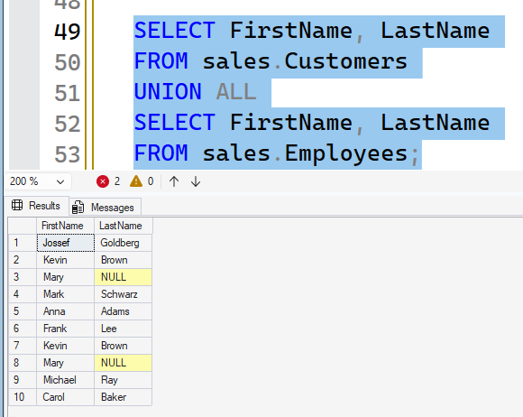

6.3 People who are both customers and employees
SQL

SELECT FirstName, LastName
FROM sales.Customers
INTERSECT
SELECT FirstName, LastName
FROM sales.Employees;

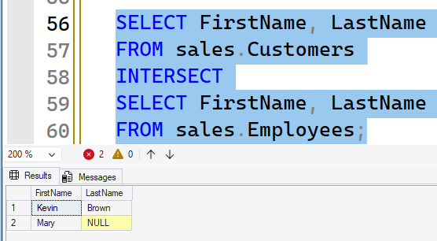
6.4 Customers who are not employees
SQL

SELECT FirstName, LastName
FROM sales.Customers
EXCEPT
SELECT FirstName, LastName
FROM sales.Employees;

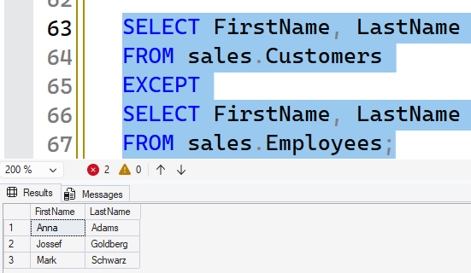
6.5 Combine both tables with PersonType and sort by FirstName
SQL

SELECT FirstName,
LastName,
'Customer' AS PersonType
FROM sales.Customers
UNION ALL
SELECT FirstName,
LastName,
'Employee' AS PersonType
FROM sales.Employees
ORDER BY FirstName ASC;

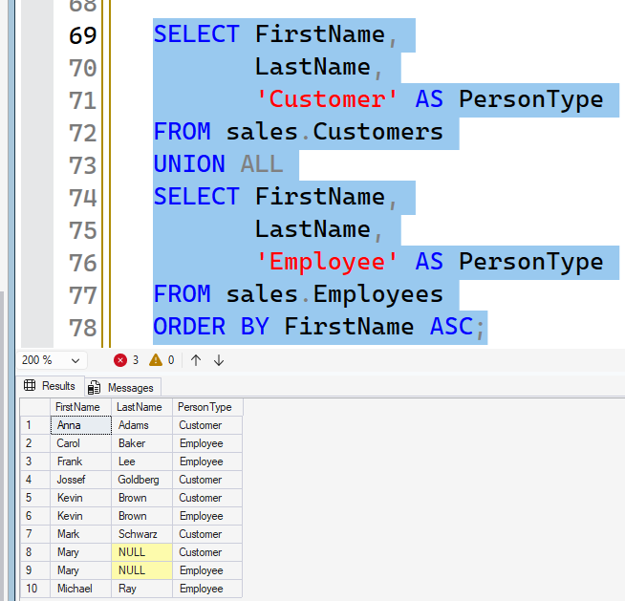
Part 7: IN and NOT IN
7.1 Customers in Pakistan, UAE or India
SQL

SELECT *
FROM Costomer
WHERE Country IN ('Pakistan', 'UAE', 'India');

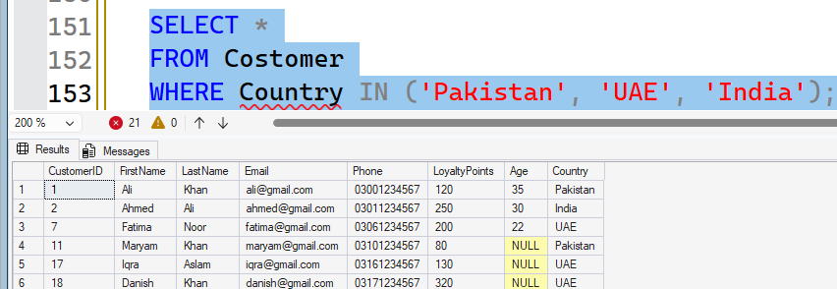
7.2 Stationery or Accessories products
SQL

SELECT Product, Category
FROM sales.Products
WHERE Category IN ('Stationery', 'Accessories');

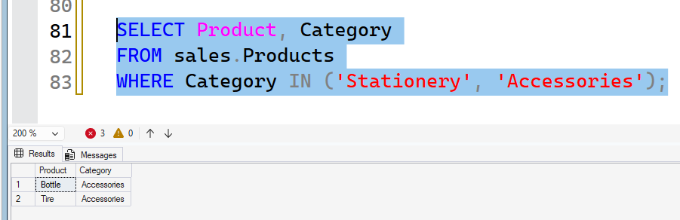
7.3 Customers not in the USA, China or Italy
SQL

SELECT *
FROM Customers
WHERE Country NOT IN ('USA', 'China', 'Italy');
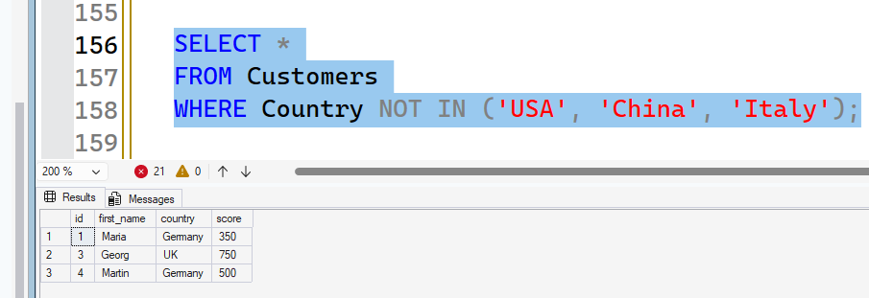
7.4 HR or Marketing employees, highest salary first
SQL

SELECT FirstName, Department, Salary
FROM sales.Employees
WHERE Department IN ('HR', 'Marketing')
ORDER BY Salary DESC;

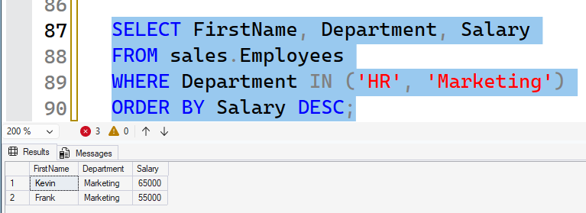
7.5 Orders that are neither Cancelled nor Pending
SQL

SELECT *
FROM sales.Orders
WHERE OrderStatus NOT IN ('Cancelled', 'Pending');

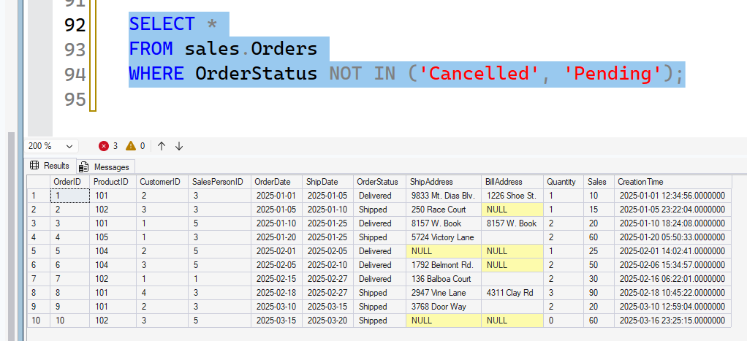
Part 8: JOINs
8.1 Every order with the customer's first name and order date
SQL

SELECT Orders.OrderID,
Customers.FirstName,
Orders.OrderDate
FROM sales.Orders
INNER JOIN sales.Customers
ON Orders.CustomerID = Customers.CustomerID;

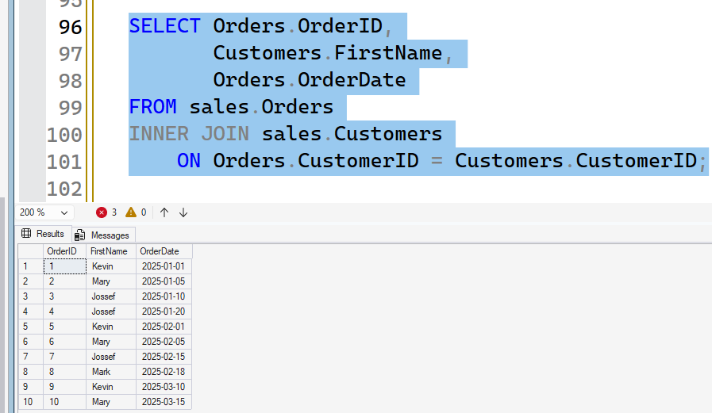
8.2 Every customer, including those who never ordered
SQL

SELECT Customers.FirstName,
Orders.OrderID
FROM sales.Customers
LEFT JOIN sales.Orders
ON Customers.CustomerID = Orders.CustomerID;

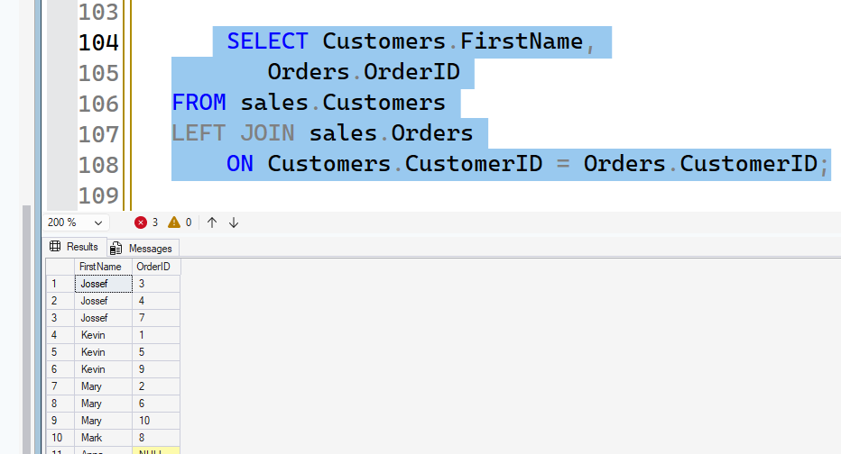
8.3 Every product with its OrderID, using RIGHT JOIN
SQL

SELECT Products.Product,
Orders.OrderID
FROM sales.Orders
RIGHT JOIN sales.Products
ON Orders.ProductID = Products.ProductID;

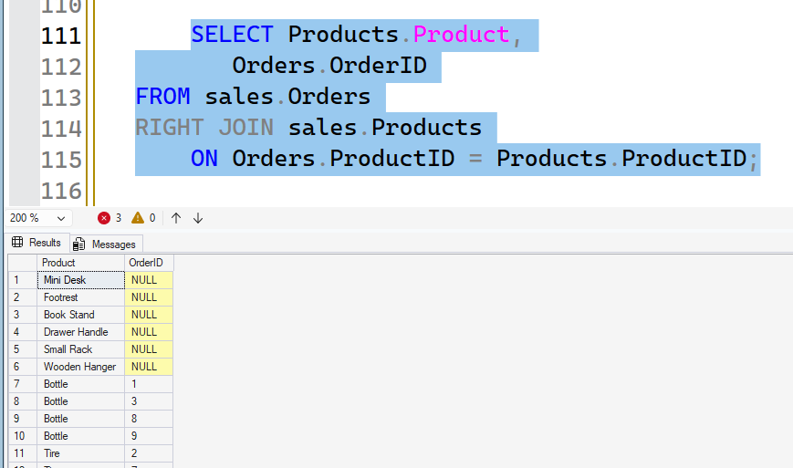
8.4 Customers who have never placed an order
SQL

SELECT Customers.FirstName,
Customers.LastName
FROM sales.Customers
LEFT JOIN sales.Orders
ON Customers.CustomerID = Orders.CustomerID
WHERE Orders.OrderID IS NULL;

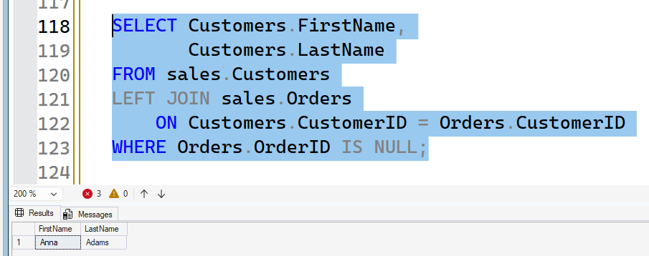
8.5 Delivered orders with customer, product, date and quantity
SQL

SELECT Customers.FirstName,
Products.Product,
Orders.OrderDate,
Orders.Quantity
FROM sales.Orders
INNER JOIN sales.Customers
ON Orders.CustomerID = Customers.CustomerID
INNER JOIN sales.Products
ON Orders.ProductID = Products.ProductID
WHERE OrderStatus = 'Delivered';

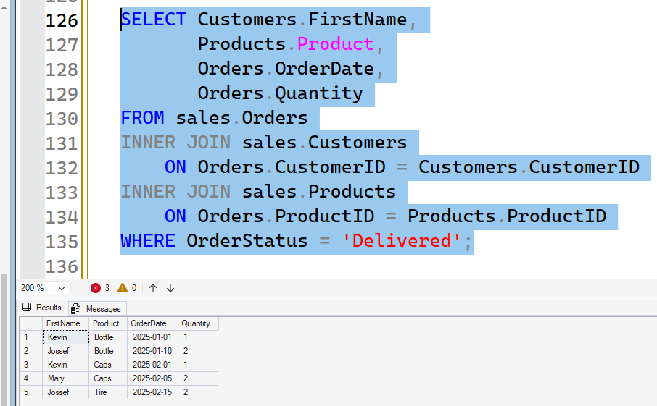
Part 9: Subqueries
9.1 Products costing more than Desk Lamp
SQL

SELECT Product, Price
FROM sales.Products
WHERE Price > (
SELECT Price
FROM sales.Products
WHERE Product = 'Desk Lamp'
);

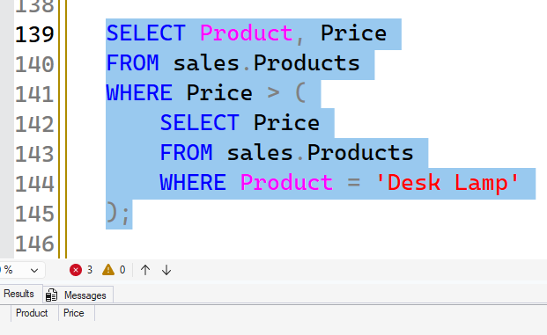
9.2 Products costing more than the average price
SQL

SELECT Product, Price
FROM sales.Products
WHERE Price > (
SELECT AVG(Price)
FROM sales.Products
);

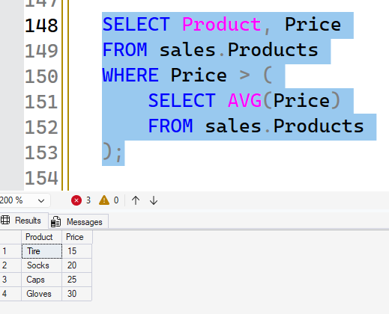
9.3 Customers who have placed at least one order
SQL

SELECT FirstName, LastName
FROM sales.Customers
WHERE CustomerID IN (
SELECT CustomerID
FROM sales.Orders
);

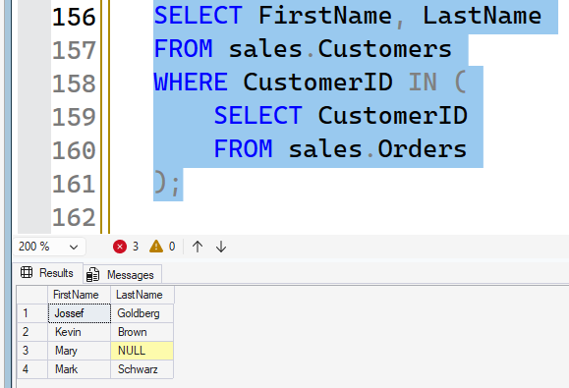
9.4 Products that have never been ordered
SQL

SELECT Product
FROM sales.Products
WHERE ProductID NOT IN (
SELECT ProductID
FROM sales.Orders
);

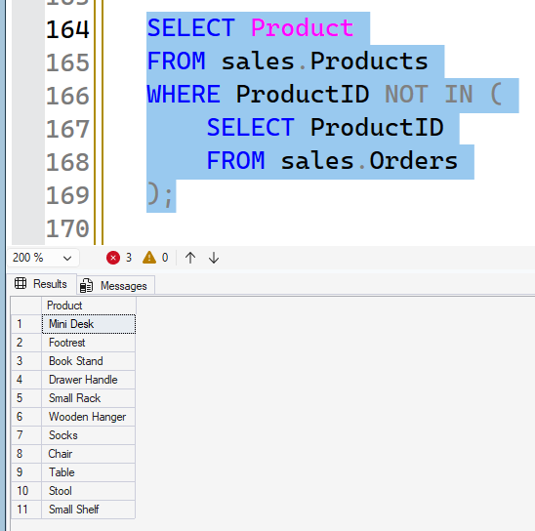
9.5 Customers who ordered at least one Electronics product
SQL

SELECT FirstName, LastName
FROM sales.Customers
WHERE CustomerID IN (
SELECT CustomerID
FROM sales.Orders
WHERE ProductID IN (
SELECT ProductID
FROM sales.Products
WHERE Category = 'Electronics'
)
);

